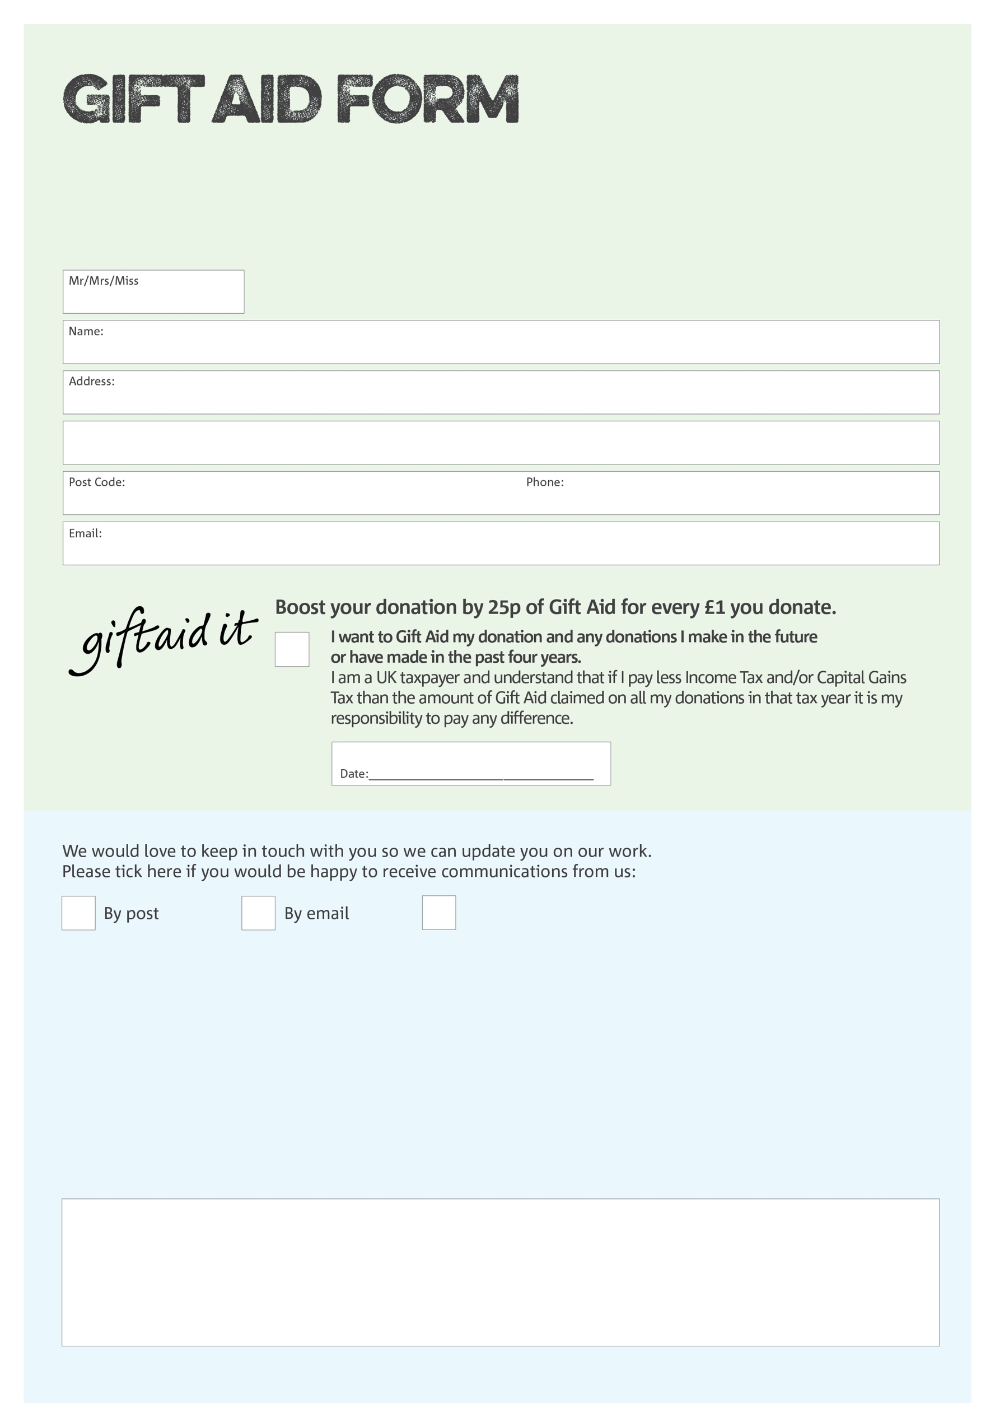

By filling in this form Hastings Foodbank will receive an extra 25p for every £1 you give at no extra cost to you. Thank you!

How have you donated? □ Cash  □ Cheque □ Bank transfer

You can change your preferences any time by contacting us on 07526 066453 or emailing us at

info@hastings.foodbank.org.uk

I do not wish to receive future communications from Hastings Foodbank

**Data protection**

Hastings Foodbank is committed to protecting your privacy and will process your personal data in accordance with current Data Protection legislation. A full data privacy statement for financial donors is available from the foodbank on request.

We would love to know why you have chosen to donate to Hastings Foodbank. If you would like to share your motivation let us know below:

Charity Number 1081252. Registered in England and Wales